Case 19-AM,C-Taino-Mask-Yucahuguamá-Skeletal-Vesicular Andesite

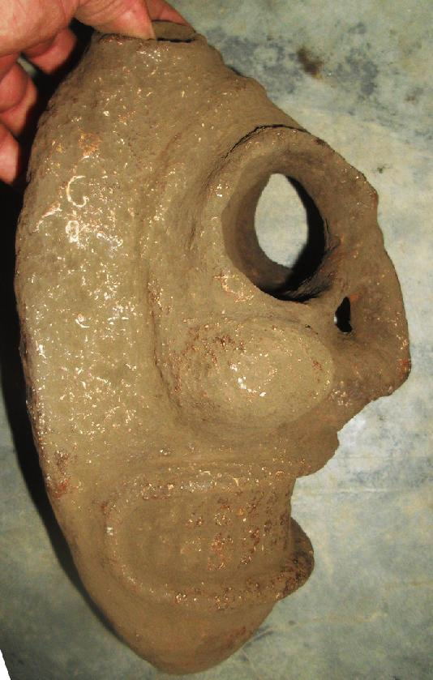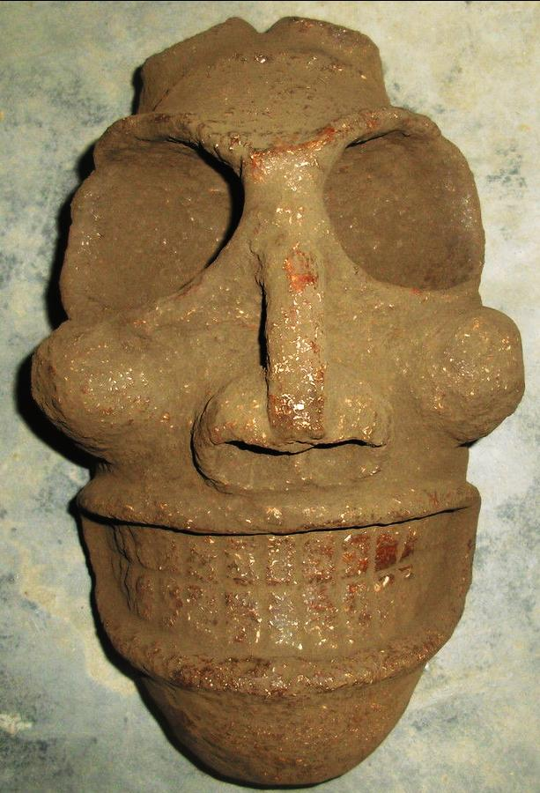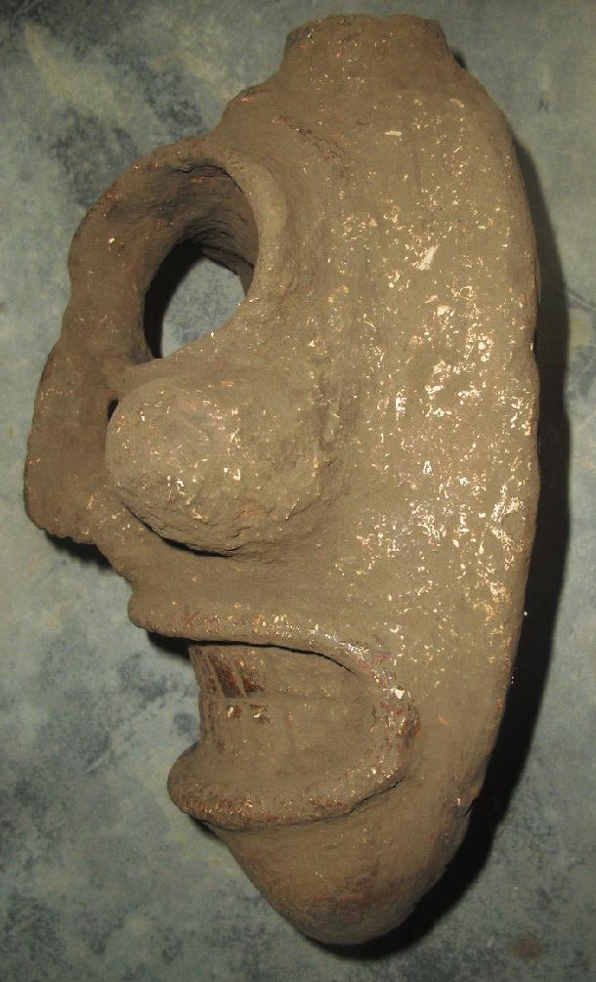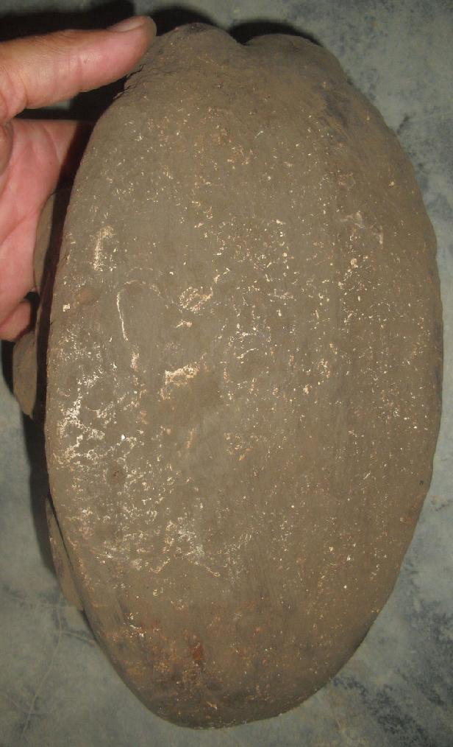
AM,C-Taino-Mask-Yucahuguamá-Skeletal-Vesicular Andesite
Case No.: 19
Accession Number:
Formal Label: AM,C-Taino-Mask-Yucahuguamá-Skeletal-Vesicular Andesite
Display Description:
The deity or lord of the yucca was Yucahuguamá which translates as “cacique of the yucca” (Zayas y Alfonso 1914: 247, “indio principal”; Bidó 2014:92, “ Señor, Cacique”). In a portion of Christopher Columbus’ diary quoted by his son Ferdinand it was recorded “It once happened that some Christians [Columbus’ men] entered such a house [with cemís] with them [the Taínos], and the cemí gave a loud cry and spoke in their language, from which it became clear that the statue was artfully constructed. It was in fact hollow, and to the lower part was attached a blowgun or trumpet which was connected to a dark side of the house, covered by branches and leaves, where was hidden a person who said whatever the cacique wanted him to say … .” (Colón 1959, Ch. 62, 151-152.)

LC Classification: F1619.2
Date or Time Horizon:
Geographical Area: Caribbean
Map:
GPS Coordinates:
Cultural Affiliation: Taino
Medium: vesicular andesite
Dimensions:
Weight:
Provenance:
Condition: original
Discussion:
References:
Bidó, Rafael Garcia. 2014. Voces de Bohio vocabulario la cultura Taína. 2nd ed. Santo Domingo: the author.

Colón, Fernando. [1959] The life of the admiral Christopher Columbus. Translated from Historie del S.D. Colombo Fernando; nelle qualis'ha paritcolare, & vera relatione della vita, & de' fatti dell'Ammiraglio D. Cristoforo Colombo, suo padre, annotated, and with a new introduction by Benjamin Keen. New Brunswick, N.J.: Rutgers University Press, [1959]

Bercht, Fatima; Ricardo E Alegría. 1998. Zayas y Alfonso, Alfredo. 1914. Lexicografia antillana. Diccionario de voces usadas por los aborigines de las antillas mayors y algunas de las menorees y considerations acerca de su significado y de su formación. Havana: El Siglo XX de Aurelio Miranda.. Museo del Barrio: New York.

Roberts, Larry; Josh Roberts; Richard Rossetto. [2014] Taíno sculpture: art of the gods. Micanopy, FL : Signature Book Printing, p.

Zayas y Alfonso, Alfredo. 1914. Lexicografia antillana. Diccionario de voces usadas por los aborigines de las antillas mayors y algunas de las menorees y considerations acerca de su significado y de su formación. Havana: El Siglo XX de Aurelio Miranda.

Delivery package 1 of 1
Estimated delivery Friday, Apr 29, 2016 - Wednesday, May 18, 2016
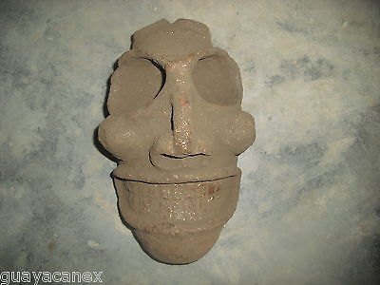

Taino head of stone
Item price | $399.00
Quantity | 1
Item number | 331798108152
Shipping service | Economy Shipping
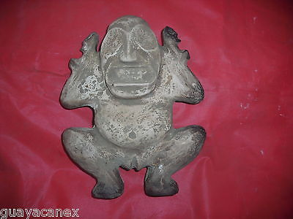

Taino Zemi of stone/mother earth in excellent condition
Item price | $199.00
Quantity | 1
Item number | 331798113138
Shipping service | Economy Shipping

Shipping address

Ralph J Coffman Jr
149 Atlantic Ave
Swampscott MA 01907-2427
United States

Order total

Subtotal | $598.00
Shipping | Free
Total
$598.00

Order placed on
Wednesday, Mar 16, 2016
Payment method
PayPal
Payment date
Wednesday, Mar 16, 2016

